Senior Capstone Project Background Preparation
Herring River (Wellfleet) Study

Tittle: Comparing and contrasting a dike limited estuary vs. an open tidal flow system
Community Service Goals:

- Conduct a study which investigates the dynamics of a tide restricted salt marsh.
- Create a data set that may identify patterns which can be used to initiate future projects to conserve Cape Cod Estuaries in the Monomoy Regional School District.

Unit Objectives

To describe the current condition of a tide restricted salt marsh estuary relative to vegetations patterns and physical and chemical parameters.

Principle 1: Estuaries are interconnected with the world ocean and with major systems and cycles on Earth.

Estuaries are part of important biological, chemical and physical cycles such as food webs, nutrient cycles, and hydrologic cycles. For example, estuarine salt marshes can sequester carbon and filter out toxic substances or nutrients from groundwater.

Principle 2: Estuaries are dynamic ecosystems with tremendous variability within and between them in physical, chemical, and biological components.

Estuaries can also change quickly, within hours or days. They are constantly shaped by water flowing from uplands as well as tidal cycles moving and mixing of fresh and salt water within the estuary. They can be dramatically changed by single, severe events such as a hurricane or the building of a levee.

Principle 4: Ongoing research and monitoring is needed to increase our understanding of estuaries and to improve our ability to protect and sustain them.

Since estuaries incorporate many interacting factors and conditions, research investigations must be carefully designed and results must be considered in context.
Principle 5: Humans, even those living far from the coast, rely on goods and services supplied by estuaries .
Concepts:
- Estuaries provide social services and cultural value to humans. Millions of people use estuaries for recreational activities such as fishing, bird watching, and boating. Estuaries are also a source of inspiration, rejuvenation and discovery. Estuaries have played an important role in determining the lifestyle and culture of different human populations overtime.

Principle 6: Human activities can impact estuaries by degrading water quality or altering habitats; therefore, we are responsible for making decisions to protect and maintain the health of estuaries.
Concepts:
- Human activities within an estuary system, its watershed, and in distant areas impact the biological, chemical, and physical components of estuaries. In particular, land use changes within an estuary’s watershed can change erosion and subsequent sedimentation rates within the estuary, affecting water clarity or bottom substrate.
- The quantity and quality of goods and services provided by estuaries to humans is dependent on the good health of estuarine ecosystems. Real estate values can decline in areas near over enriched or eutrophic estuaries.

“Scientific inquiry and experimentation should not be taught or tested as separate, stand-alone skills. Rather, opportunities for inquiry and experimentation should arise within a well-planned curriculum in the domains of science. They should be assessed through examples drawn from the life, physical, and earth and space science standards so that it is clear to students that in science, what is known does not stand separate from how it is known (MA Science Curriculum Frameworks).”

To understand the relationship between social, civic and scientific components of environmental action to restore a degraded salt marsh.

To use scientific study and data collection to better understand the complexity of real world environmental problems.

To experience both qualitative and quantitative methods in the field to build or contribute to a long term dataset.

To use scientific tools (GPS, maps, CBL, water test kits, laptop computer) to collect and process field data (chemical, physical and biological).

To understand restoration ecology by participating in a project with environmental professionals.

To get hands-on experience in conducting environmental fieldwork.

“Change happens when people believe in themselves and in their ability to contribute to a change (Gordon Peabody, Safe Harbor Environmental).”

MA State Biology Standards addressed

6.1 Explain how biotic and abiotic factors cycle in an ecosystem (water, carbon, oxygen, and nitrogen).

6.2 Use a food web to identify and distinguish producers, consumers, and decomposers, and explain the transfer of energy through trophic levels.

6.3 Identify the factors in an ecosystem that influence fluctuations in population size.

6.4 Analyze changes in an ecosystem resulting from natural causes, changes in climate, human activity, or introduction of non-native species.

Introduction
Wetlands have many values. The stems and leaves of wetland plants trap eroded soil washing from the land and absorb the energy of storm waters. Nutrients that might over enrich the waterways are trapped and used by wetland plants for growth. When these plants die, they enrich the waterways with decaying matter called detritus, a vital food source for microscopic organisms near the base of the food chain. Countless aquatic animals find food and shelter in wetlands including juveniles of many commercially valuable fishes, such as striped bass, and crustaceans, such as crabs and lobsters. An array of wading birds, song birds, waterfowl and birds of prey are attracted to wetlands for food and nest sites. Salt marshes are among the most productive natural plant communities on Earth.

Historically, wetlands have been devalued and vilified by humanity. Blamed as sources of insect pests, they were ditched and drained. Often close to dredging operations, they were covered with dredge spoil. Considered inconvenient barriers between humans and waterways, they were dredged or regulated by dikes in some places and filled in others for the construction of marinas and waterfront homes.

“One hundred years ago in Wellfleet, Massachusetts, Town officials decided to build a dike at the mouth of the Herring River. At the time, the river was the lifeblood of one the largest and most productive coastal wetland systems in New England. But during that era the immense benefits and values of wetlands were ignored and the desire to “…exterminate the mosquito pest…” and “…drain the marshes so they may be brought into valuable land…”led to the construction of a dike at Chequessett Neck Road in order to “…exclude the sea” (report of Whitman and Howard on Proposed Dike at Herring River, 1906).” (Herring River restoration pamphlet)

“During the ensuing decades, the vital role of wetlands has been widely recognized. Wetlands are protected by strong laws and many government agencies and non-government organizations are actively involved in efforts to restore and improve the ecological health of wetlands damaged by past human activity. New England’s largest and most ambitious project of this kind—the Herring River Restoration Project—presents an exceptional opportunity to turn back the ecological clock.” (Herring River restoration pamphlet)

In this project Harwich High School Environmental Studies students will have the opportunity to participate in purposeful environmental monitoring to establish a baseline for future studies and establish a database of changes over time. The data collected may be helpful in following the changes that occur as a result of the Herring River Restoration Project. Students will also have an opportunity to meet with environmental professionals to discuss the rationale and details of the project. This is a “living unit”, as it progresses; students will collaboratively make changes to fit the direction and needs of the study.

Future investigations
Earth Science Module
Activity 1: Observing Estuaries
Activity 2: Salinity & Tides

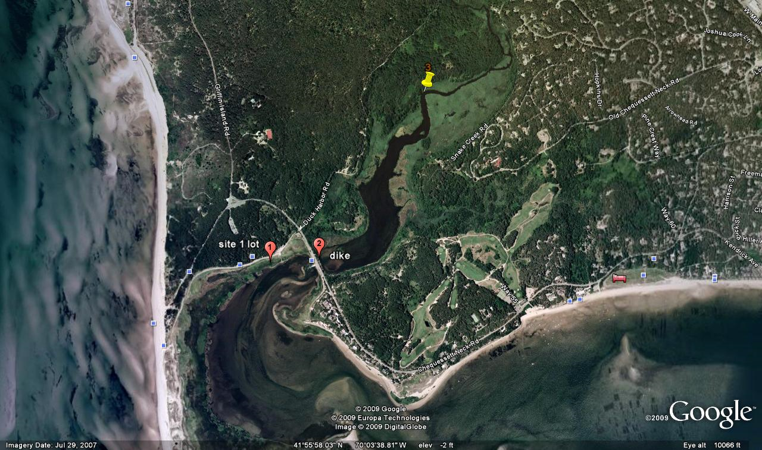

Resources

Herring River Restoration Project Update (Town of Wellfleet MA) www.wellfleetma.org/Public_Documents/WellfleetMA_WebDocs/Brochure.pdf

Safe Harbor Environmental
www.safeharborenv.com/salt-marsh-restoration/

A Protocol for the Long-term Coastal Ecosystem Monitoring Program
at Cape Cod National Seashore, J.Roman
http://science.nature.nps.gov/im/monitor/protocols/caco_marshveg.pdf

Procedure

Before the first fieldtrip
- PowerPoint presentation introduction of the Herring River Restoration Project.
- A Google Earth tour of the Herring River watershed and tidal crossing restriction site
- Review of brochure and website assignments.
- Prepare / design data sampling materials. (see Material design under procedure 1)
- Review and practice data collection and transect methods to be used at the site.
- Meet with Gordon Peabody, Safe Harbor to discuss the project “big picture”
- Assign “big Picture” discussion questions*.
- Review FT safety issues, procedures and transportation.

Fieldtrip 1 A snapshot of biological differences between unrestricted and restricted tidal flow areas in the Herring River watershed
  - A walking tour of low marsh, tidal crossing and high marsh in both salt water and brackish areas..
  - Rapid transect to assess species dominance and zonation. (Students are instructed to run a transect from upland edge of high marsh to low tide water’s edge, collecting and counting species encountered along the transect and their “zone” as measured from the high tide mark).
  - Show and tell session to share data collected.
  - Transcribe data and create transect graphic showing elevations and characteristic species.
Fieldtrip 2 Set-up, GPS location of monitoring sites and chemical testing of areas above and below the dike.
- physical description
- Chemical data collected
- Rapid transects of sampling sites
Follow-up (after each trip)
- Organize, share and discuss collected data.
- Discuss answers to “big Picture” questions. ( Wetlands Investigation Discussion document).
- Discuss trends and plan future investigation adaptations.
- Create (and update) website to display and share data.

Field Lab Procedure 1 (on sight baseline transect data collection) adapted from Bennett and Rey, An Examination of Marsh Grass Diversity in a Brackish Marsh, 1998. (http://www.qacps.k12.md.us/cms/sci/PROJSBMR.HTM#abs#abs)
Vegetation Comparison: When the tidal range is reduced, the upstream habitat may no longer be dominated by salt-marsh grasses, but instead may contain less salt-tolerant species such as common reed (Phragmites australis) or freshwater species such as cattails (Typha sp.). In extreme cases, the habitat may evolve into shrub or forested swamp, and the former wetland may be invaded by upland species.
Analyzing the differences in vegetation from upstream to downstream can take a trained eye, especially since the differences may be subtle. Moreover, the differences may not be related to a restriction of salt water.
The habitat both upstream and downstream is assessed visually, and any difference in frequency of salt-tolerant and salt-intolerant plant species is recorded on the data sheet using the classification scheme below.

Essential Questions
Does the change in elevation in a brackish salt marsh affect the distribution of marsh plant and animal species?
How does diversity change over an elevation gradient in the marsh?
How does diversity differ between a tidally restricted vs. an open estuary?
What changes will occur over time as a result of the Herring River Restoration Project (long term)?

Glossary
Anadromous: Fish which migrate up rivers from the sea to breed.
Brackish Marsh: A wetland that is fed by both fresh water and salt water.
Detritus: Fragment material produced by weathering and decomposition.
Erosion: The loss of land associated with weathering.
Estuary: The mouth of a river where fresh and salt water intermix.
High Marsh: The higher elevation of the salt marsh which is dominated by short coarse grasses.
Low Marsh: The lower elevation of the salt marsh which is dominated by the taller smooth grasses.
Phragmites (Phragmites australis): A tall invasive reed that colonizes the edges of saltt marshes and can replace low-lying salt-tolerant grassspecies.
Pooling: The accumulation of water at an erosion area.
Salt Marsh: Low-lying wetlands periodically inundated by tides.
Tidal Crossing: A bridge or culvert that allows tides to flow under road or embankment.
Tidal Crossing Ratio: The difference between the width of the crossing opening and the width of the stream channel.
Tidal Range: The change in tide level between low tide and high tide measured at a given location.
Tidal Range Differential: The difference between the upstream and downstream tidal ranges.
Tidal Range Ratio: The ratio between the upstream and downstream tidal ranges.
Tidal Restriction: Tidal crossing that impedes the ebb and flow of tides.
Upland: Land where soils are not saturated by water.

